1. . Design DFA using simulator to accept the string the end with ab over set {a,b)

W= aaabab

INPUT:

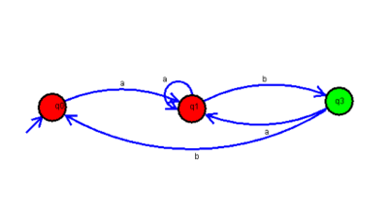

OUTPUT:

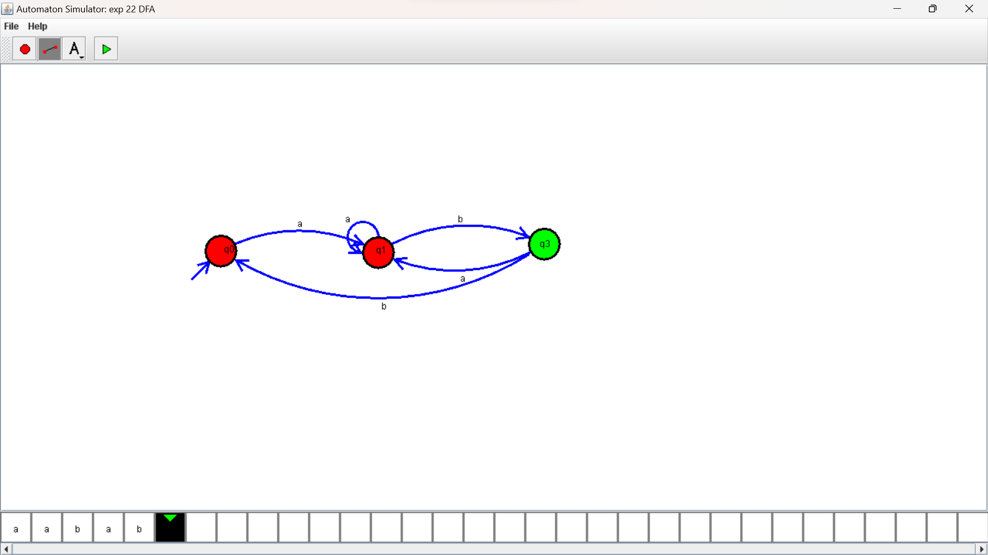

RESULTS;

DFA using simulator to accept the string the end with ab over set {a,b)

W= aaabab